Jennifer Ahamad

4/15/2024

Professor Ali Yares

CMST 385 7380

**CLIENT AND TOPIC**

This proposal will be an outline of a business that is owned by someone else. The website will show what type of business it is and show what type of clients it wants to cater too.

**DEVELOPMENT PROCESS AND ENGAGEMENT**

This website is being made for a client. To get them involved with the development process I will ask them what kind of information they want to include on the site, what type of customer you are looking for, what other businesses you are up against. I might need to ask what their goals are for the site.

I will also do some research to see what other businesses in the same field are doing. I will see what type of features they might have and how this website could attract more business.

**TESTING**

While making the website I will need to test it. I will test it with different browsers to make sure the design works in any browser that a potential customer may use. I will test in chrome, Firefox, and Microsoft edge. I will also make sure I test different screen sizes on different devices to make sure the website can be viewed anywhere on any screen.

**Goal**

The goal of the business is to make personalized travel packages for its customers.

**Purpose**

The purpose of the website is to show travel destinations that the customer likes to go. Provide the customer with easy booking options and information. Offer resources that might pertain to the customers’ needs.

**Target**

The target is quite a wide range. They would be people traveling between the ages of 25-55, wanting unique travel experiences. They have disposable income of $100,000, and they can access information through online searches and social media, but they are also budget-conscious, students, groups and seniors.

People who are with corporations and nonprofit groups that need to go for a business trip, retreats, field trips or fund raisers.

People that like adventure might be going on their honeymoon or just want to go sightseeing.

**Competition**

The main competition for the business booking.com, and Expedia. These are two big names in the travel agency that everyone has heard of.

**Impact**

The impact of the targeting audience will make the website. The target audience will let the business know what type of travel they want and what type of marketing strategies will be needed.

**Updates**

The website will be updated when new travel packages are available. Whenever hotels have cheap dates, and any discounts going on. When a travel tip is available.

**5. GROWTH AND MAINTENANCE (50-word minimum)**

The website will grow with new destinations, and travel packages. Developing a user-friendly website will make maintenance easier. The website will start with updates on the content, it will include weekly security checks and checks on performance.

I will need to check all the links to make sure they are working properly and going to the right location. The website will be backup on a weekly schedule. To make sure if a problem happens the website can be up in running in a short amount of time. Making a backup will make sure that data is not losses.

**ORGANIZATION**

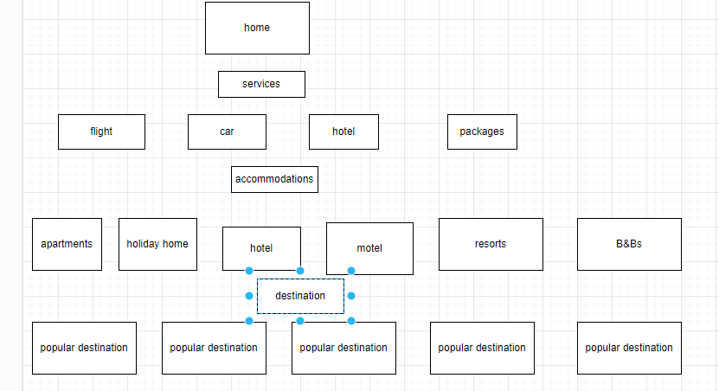  
The webpage will have the main services that will be offered. Then you will have packages. The sub-topics will be what the services can offer that might interest the customer. There will be other pages that each topic will go to so the person can book what they are looking for.

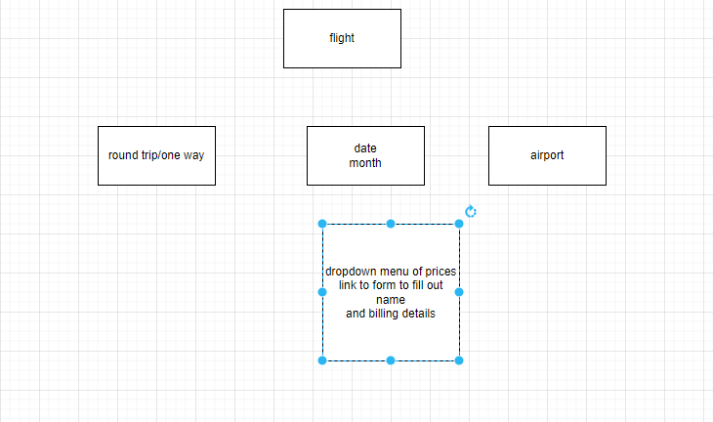

**WEB HOSTING**

I would need to choose a site with VPS. It will be a little bit more costly, but it will provide a faster and better-quality web performance. This performance will give a better customer experience compared to a website with a limited bandwidth. A VPS host is for websites that anticipate more traffic.

A special tech that would be necessary for the website would be Ruby on Rails. Ruby on rails is a server-side web application development. It has a default structure for databases, web pages and services. It uses web standards for data transfer for user interfaces. Ruby on Rails has its own programming language to develop web applications. It has its own built-in testing.

**8. MARKETING**

**Domain Name**

World-travel.vactions

I chose this domain name because people always like to dream to go all around the world and most of the time it is done on vacation.

To market my website, I would use social media. Most people spend a lot of their spare time on social media just scrolling through their feeds. By using Instagram and Facebook I can put out an ad to get people to come to my website to check it out.

**SECURITY**

There is no user-account required to use the website. Letting customers use the site and book travel will encourage customers to use the site and to come back again.

There will be no password because of the content of the website. The website is to provide travel and booking service to visitors adding a password would not give the user a good experience and most people do not like make accounts.

As a web designer and developer some of the steps to secure the website would be to have SSL encryption to secure data transmission. To have regular updates and plugins to patch any vulnerabilities. To make sure passwords are strong and unique, make sure that the firewall is enabled and conduct regular security audits.

The website would implement CAPTCHA to prevent automated attacks and make sure access is limited to sensitive directories to keep the website secure.

# References

Morris, C. (2024, February 16). *12 Website Marketing Strategies for Growing your Business in 2024*. Retrieved from elegant: https://www.elegantthemes.com/blog/marketing/website-marketing-strategies

*Ruby on Rails introduction*. (2021, March 10). Retrieved from geeks for geeks: https://www.geeksforgeeks.org/ruby-on-rails-introduction/

Stevens, G. (2024, April 10). *10 Tips for Choosing the Right Web Hosting Company*. Retrieved from Marketing Solutions: https://www.business.com/articles/10-tips-for-choosing-the-right-web-hosting-company/

*What is Website Maintenance and Why is it Necessary*. (n.d.). Retrieved from Intuit Mailchimp: https://mailchimp.com/resources/website-maintenance/